Trig Functions

Definition: If x is an angle in radians, then the following are trigonometric functions:
f(x) = sin x
f(x) = cos x
f(x) = tan x

Graph f(x) = sin x. This is the same as y= sin x and y = sin(x)

x | y |  | x | y |  | x | y
0 | 0 |  | π | 0 |  | 0 | 0
 |  |  | $$\frac{7π}{6}$$ | - |  | $$\frac{\text{13}π}{6}$$
$$\frac{π}{4}$$ | $$\frac{\sqrt{2}}{2}≈0\text{.}7$$ |  | $$\frac{5π}{4}$$ | $$\frac{−\sqrt{2}}{2}≈−0\text{.}7$$ |  | $$\frac{9π}{4}$$ | $$\frac{\sqrt{2}}{2}≈0\text{.}7$$
$$\frac{π}{3}$$ | $$\frac{\sqrt{3}}{2}≈0\text{.}\text{87}$$ |  |  | $$\frac{−\sqrt{3}}{2}≈−0\text{.}\text{87}$$ |  | $$\frac{7π}{3}$$ | $$\frac{\sqrt{3}}{2}≈0\text{.}\text{87}$$
$$\frac{π}{2}$$ | 1 |  | $$\frac{3π}{2}$$ | -1 |  | $$\frac{5π}{2}$$ | 1
$$\frac{2π}{3}$$ | $$\frac{\sqrt{3}}{2}≈0\text{.}\text{87}$$ |  | $$\frac{5π}{3}$$ | $$\frac{−\sqrt{3}}{2}≈−0\text{.}\text{87}$$ |  | $$\frac{8π}{3}$$ | $$\frac{\sqrt{3}}{2}≈0\text{.}\text{87}$$
$$\frac{3π}{4}$$ | $$\frac{\sqrt{2}}{2}≈0\text{.}7$$ |  | $$\frac{7π}{4}$$ | $$\frac{−\sqrt{2}}{2}≈−0\text{.}7$$ |  | $$\frac{\text{11}π}{4}$$ | $$\frac{\sqrt{2}}{2}≈0\text{.}7$$
$$\frac{5π}{6}$$ |  |  | $$\frac{\text{11}π}{6}$$ | - |  | $$\frac{\text{17}π}{6}$$
$$π$$ | 0 |  | 2$π$ | 0 |  | 3$π$ | 0

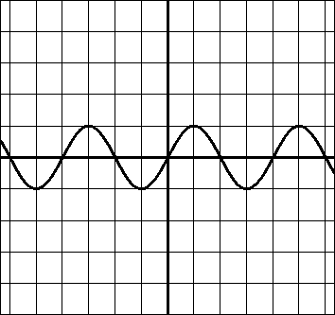
0
2π
-π
-2π
π
1
-1

The Domain of y=sin x is the set of all real numbers.
The Range of y = sin x is -1 ≤ y ≤ 1.

The portion of the graph of y = sin x that includes one period is called one cycle of the sine curve.

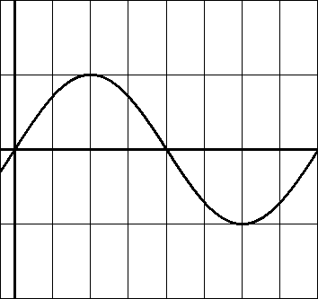
π
0
2π
$$\frac{π}{2}$$
$$\frac{3π}{2}$$
1
-1

Every period of the sine curve has 5 key points: the intercepts and a minimum and maximum point.

For one period of the sine curve, the x-intercepts occur at (0, 0), (π, 0), and (2π, 0). The maximum point is (π/2, 1) and the minimum point is (3π/2, -1).

Graph y = cos x.

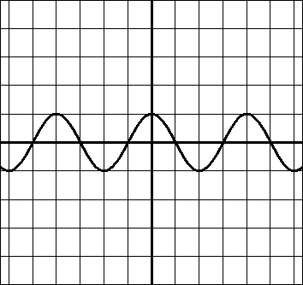
0
2π
-π
-2π
π
1
-1

The Domain of y = cos x is the set of all real numbers.
The Range of y = cos x is -1 ≤ y ≤ 1.

The portion of the graph of y = cos x that includes one period is called one cycle of the cosine curve.

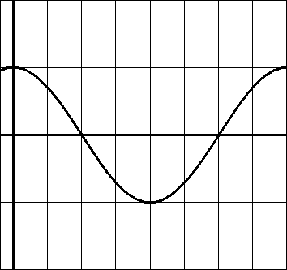
2π
π
0
1
-1

Every period of the cosine curve has 5 key points: the intercepts and a minimum and maximum point.

For one period of the sine curve, the x-intercepts occur at (π/2, 0), and (3π/2, 0). The maximum point is (0, 1) and (2π, 0) and the minimum point is (π, -1).

**Both sine and cosine curves have a period of 2π. We consider the interval from 0 to 2π as the basic cycle.

Graph y = tan x.

x | y |  | 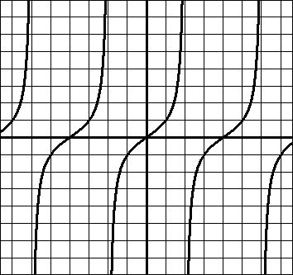  $$\frac{−3π}{2}$$  $$\frac{π}{2}$$  $$\frac{−π}{2}$$  $$\frac{3π}{2}$$
0 | 0
 | $$\frac{\sqrt{3}}{3}≈\text{.}\text{58}$$
$$\frac{π}{4}$$ | 1
$$\frac{π}{3}$$ | $$\sqrt{3}≈1\text{.}7$$
$$\frac{π}{2}$$ | undefined
$$\frac{2π}{3}$$ | $$−\sqrt{3}≈−1\text{.}7$$
$$\frac{3π}{4}$$ | -1
$$\frac{5π}{6}$$ | $$\frac{−\sqrt{3}}{3}≈−\text{.}\text{58}$$
$$π$$ | 0

The Domain is all real numbers except multiples of $\frac{π}{2}$.
(We say the domain is all x ≠ $\frac{π}{2}$ + nπ)

The Range is the set of all real numbers.
y = tan x

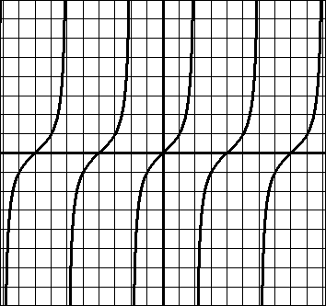

- The period for tangent is π.
- One cycle is $\frac{−π}{2}$ < x < $\frac{π}{2}$. (Note that it’s not ≤ )
- One cycle goes from $\frac{−π}{2}$ to $\frac{π}{2}$.
- There is a vertical asymptote at x = $\frac{π}{2}$ ± nπ (at every x-value for which the tangent is undefined.)
- The Domain is all x ≠ $\frac{π}{2}$ + nπ
- The Range is all real numbers.

- All three trig functions are periodic functions because there is a repeating pattern.

  - For sine and cosine, the basic period is 2π.
  - For tangent, the basic period is π.

- The graphs of sine and cosine are continuous because there are no breaks.

- The graph of tangent is discontinuous because there are jumps/breaks (where the asymptotes are).

Amplitude

On a graphing calculator, graph y = sin x
y = 2sin x
y = 5sin x
y = ½ sin x

What can you conclude?

As the number being multiplied out front increases, the graph of y = sin x stretches vertically.

Definition: The amplitude of y = a sin x and y = a cos x represents half the distance between the maximum and minimum values of the function and is given by Amplitude = |a|.

*Note: If a is a negative number, the graph of the function will be reflected over the x-axis.

Example: Graph y = -sin x.
Graph y = -2sinx.

See that these are the same as y = sin x and y = 2sin x, but they are “up-side-down.”

Example of amplitudes:

The amplitude of y = sin x is 1.
The amplitude of y = 2 sin x is 2.
The amplitude of y = 5 sin x is 5.
The amplitude of y = ½ sin x is ½ .
The amplitude of y = -13 sin x is 13. (not -13)

Graph y = 4 sin x

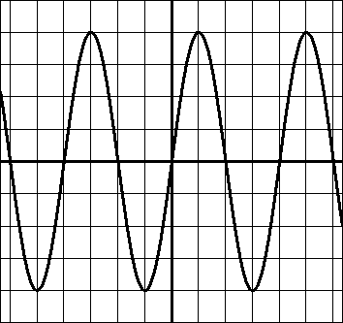
0
2π
-π
-2π
π
1
-1
4
-4

The period remains the same, but the amplitude changes.

Graph y = 3 cos x

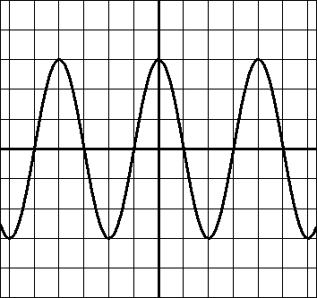
0
2π
-π
-2π
π
1
-1
-3
-3
Graph y = -2 cos x

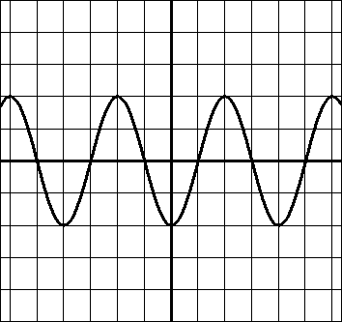
0
2π
-π
-2π
π
2
-2

Changing the Period of Sine and Cosine

On a graphing calculator graph: y = sin x
y = sin 2x

What do you notice?

The length of one cycle is half as long for y = sin 2x.

Definition: Let b be a positive real number. The period of y = a sin bx and y = a cos bx is 2π/b.

Example: Find the period of $y=\text{cos}6x$.

The period = $\frac{2π}{b}=\frac{2π}{6}=\frac{π}{3}$

Example: Find the period of y = sin $\frac{x}{5}$.

The period = $\frac{2π}{b}=\frac{2π}{\frac{1}{5}}=2π⋅\frac{5}{1}=\text{10}π$

Note: Once you know the basic shape of the sine and cosine curves, it is basically a matter of making adjustments to the axes labels.

Example: Graph y = 3sin 4x.

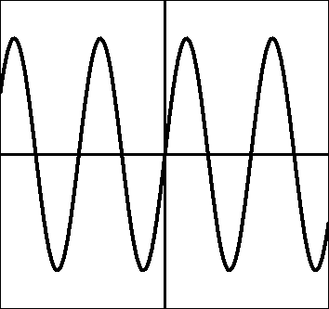
3
-3
$$\frac{π}{2}$$
$$\frac{−π}{2}$$
$$\frac{π}{4}$$
$$\frac{−π}{4}$$

