Conic Sections

Each conic section is the intersection of a plane and a double-napped cone.

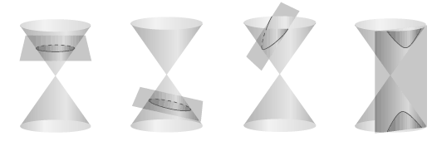
Ellipse
Hyperbola
Circle
Parabola

Three Ways to Study Conics

- Define them in terms of the intersections of planes and cones, as the Greeks did
- Define them algebraically in terms of the general 2nd degree equation

$${\text{Ax}}^{2}+\text{Bxy}+{\text{Cy}}^{2}+\text{Dx}+\text{Ey}+F=0$$

- Define each conic as a locus (collection) of points (x, y) that are equidistant from a fixed point (h, k).

Circles
Definition of a Circle

A circle is the set of all points (x, y) in a plane that are equidistant from a fixed point in the plane.

- The fixed point is called the center.
- The distance from the center to any point on the circle is the radius.

Use the Distance Formula to find the equation of a circle:

(h, k)
(x, y)
r

Standard Equation of a Circle

The standard form of the equation of a circle with vertex at (h, k) is as follows:

$$(x−h)^{2}+(y−k)^{2}=r^{2}$$

Example: If the radius = 6 and the center is at (-2, 3), find the equation of the circle.

Solution:
$$\begin{aligned}(x−h)^{2}+(y−k)^{2}=r^{2} \\ (x−(−2))^{2}+(y−3)^{2}=6^{2} \\ (x+2)^{2}+(y−3)^{2}=\text{36}\end{aligned}$$

Example: Find the center and radius of the circle if its equation is $(x−5)^{2}+(y+7)^{2}=\text{11}$

Solution:
Center: (5, -7)
Radius: $\sqrt{\text{11}}$

Example: Graph $(x−2)^{2}+(y+4)^{2}=9$

Solution: The center is (2, -4) and the radius is 3.

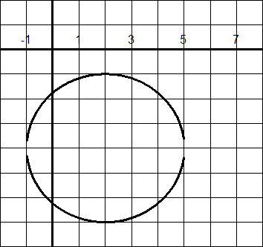

Example: Write $x^{2}−2x+y^{2}+\text{16}y=−\text{33}$ in standard form.

Solution: Complete the square twice.

$$(x^{2}−2x+1)+(y^{2}+\text{16}y+\text{64})=−\text{33}+1+\text{64}$$
$$(x−1)^{2}+(y+8)^{2}=\text{32}$$

Example: Write $x^{2}+y^{2}+8x−\text{22}y+\text{56}=0$ in standard form.

Solution: Complete the square twice.

$$\begin{aligned}(x^{2}+8x+\text{16})+(y^{2}−\text{22}y+\text{121})=−\text{56}+\text{16}+\text{121} \\ (x+4)^{2}+(y−\text{11})^{2}=\text{81}\end{aligned}$$

Parabolas

We have previously looked at parabolas as quadratic functions in the form

$$f(x)={\text{ax}}^{2}+\text{bx}+c$$

This parabola opens upward if a is positive and downward if a is negative. In addition, there is a vertical stretch or shrink, depending on the absolute value of a. The larger |a| is, the narrower the parabola is.

The following definition is based on the locus of points that make up the parabola, and is independent of the orientation of the parabola.
Definition of Parabola

A parabola as the set of all points (x, y) in a plane that are equidistant from a fixed line and a fixed point not on the line.
- The fixed line is called the directrix.
- The fixed point is called the focus.
- The vertex is the midpoint between the focus and the directrix.
- The axis is the line through the focus and perpendicular to the directrix. (A parabola is always symmetric with respect to its axis.)
Axis
Directrix
d
d
Focus
Vertex

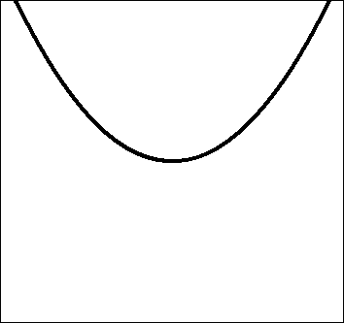

Notice that the distance from the focus to the vertex is equal to the distance from the vertex to the directrix.
If the parabola has a directrix parallel to either the x-axis or y-axis, we can derive the following standard equation using the distance formula.
Standard Equation of a Parabola

The standard form of the equation of a parabola with vertex at (h, k) is as follows:

$y=a(x−h)^{2}+k$, where $|a|=\frac{1}{4p}$

Axis: vertical
Directrix: $y=k−p$
Focus: $(h,k+p)$

$x=a(y−k)^{2}+h,$ where $|a|=\frac{1}{4p}$

Axis: horzontal
Directrix: $x=h−p$
Focus: $(h+p,k)$

The focus lies on the axis p units from the vertex. If the vertex is at the origin (0, 0), the equation takes one of the following forms.

$y={\text{ax}}^{2}$ vertical axis
$x={\text{ay}}^{2}$ horzontal axis
Example: Graph $y=\frac{1}{\text{16}}(x−3)^{2}−5$.
Also graph the focus and directrix.

Vertex: (3, -5)
Opens: up
Shape: flatter than standard
Focus: $|a|=\frac{1}{4p}$ $⇒$ $\frac{1}{\text{16}}=\frac{1}{4p}$ $⇒$ $p=4$

The focus is 4 units up from the vertex at (3, -1)

Directrix: Horizontal line 4 units down from the vertex at y = -9
Find one other point: Let x = 5. Then $y=−4\frac{3}{4}$

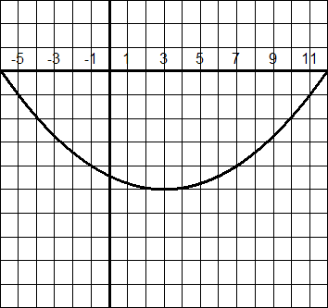

Example: Graph $x=−\frac{1}{2}(y−2)^{2}+4$.

Vertex: (4, 2)
Opens: left
Shape: flatter than standard
Focus: $|a|=\frac{1}{4p}$ $⇒$ $\frac{−1}{2}=\frac{1}{4p}$ $⇒$ $p=\frac{1}{2}$

The focus is ½ unit left of the vertex at (3½, 2)

Directrix: Vertical line ½ unit right from the vertex at x = 4½
Find one other point: Let y = 4. Then x=2.

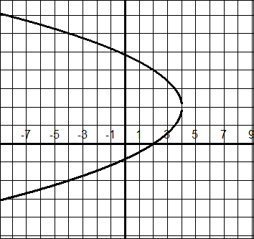

Example: Find the standard form of the equation of the parabola with vertex (4, -1) and directrix y =2.

Solution: Sketch the graph to see that p = 3.

$$\begin{aligned}|a|=\frac{1}{4p} \\ |a|=\frac{1}{\text{12}}\end{aligned}$$

Because our graph opens downward, use $a=−\frac{1}{\text{12}}$

$$y=−\frac{1}{\text{12}}(x−4)^{2}−1$$

Example: Find the standard form of the equation of the parabola with vertex (1, 5) and focus (-1, 5).

Solution: First graph these 2 points to determine the standard equation.

Because it opens to the left we use

$x=a(y−k)^{2}+h,$ where $|a|=\frac{1}{4p}$
We can see by the sketch that p = 2. Then

$$\begin{aligned}|a|=\frac{1}{4p} \\ |a|=\frac{1}{8}\end{aligned}$$

Since the parabola opens left, use $a=−\frac{1}{8}$

$$x=−\frac{1}{8}(y−5)^{2}−1$$

Ellipses

The next type of conic is called an ellipse.

d₂

d₁
Focus
Focus
(x, y)
Definition of Ellipse

An ellipse is the set of all points (x, y) in a plane, the sum of whose distances from two distinct fixed points (foci) is constant.

d₁ + d₂ is a constant.

There are a number of parts of an ellipse that should be noted:

center

major axis
Focus
Focus
vertex
vertex
minor axis
covertex
covertex

- The midpoint between the foci is the center.

- The line segment through the foci, with endpoints on the ellipses, is the major axis.

- The endpoints of the major axis are the vertices of the ellipse.

- The line segment through the center and perpendicular to the major axis, with endpoints on the ellipse, is the minor axis.

- The endpoints of the minor axis are the covertices of the ellipse.

There are 3 distances that are important when studying an ellipse.
Focus
Focus
A
A
A
b
a
c

Focus
Focus
A
A
A
b
c
a

a is always the longest length
and c is always the focal length
Standard Equation of an Ellipse

The standard form of the equation of an ellipse centered at (h, k), with major axis of length 2a, minor axis of length 2b, where 0 < b < a, is

$\frac{(x−h)^{2}}{a^{2}}+\frac{(y−k)^{2}}{b^{2}}=1$ Major axis is horizontal

$\frac{(x−h)^{2}}{b^{2}}+\frac{(y−k)^{2}}{a^{2}}=1$ Major axis is vertical

The foci lie on the major axis, c units from the center, with $c^{2}=a^{2}−b^{2}$. If the center is at the origin (0, 0), the equation takes one of the following forms.

$\frac{x^{2}}{a^{2}}+\frac{y^{2}}{b^{2}}=1$ Major axis is horizontal

$\frac{x^{2}}{b^{2}}+\frac{y^{2}}{a^{2}}=1$ Major axis is vertical

Example: Find the center, vertices, and foci of the ellipse given by 9x² + 4y² = 36.

Solution: First divide through by 36 to get the correct form.

$$\frac{x^{2}}{4}+\frac{y^{2}}{9}=1$$

Remembering that the larger number on the bottom corresponds to a, we can see that:

$b^{2}=4$ so $b=2$
$a^{2}=9$ so $a=3$

Using $c^{2}=a^{2}−b^{2}$, we can find c.

$$\begin{aligned}c^{2}=3^{2}−2^{2} \\ c^{2}=5 \\ c=\sqrt{5}\end{aligned}$$

The center of the ellipse is (0, 0). From that point:

- We go 3 units up and down for the vertices: (0,3), (0,-3)
- We go 2 units right and left for covertices: (2, 0), (-2, 0)
- We go $\sqrt{5}$ units up and down for the foci: (0,$\sqrt{5}$), (0,- $\sqrt{5}$)

Example: Find the standard form of the equation of the ellipse centered at the origin with major axis of length 10 and foci at ("3, 0).

Solution: If the major axis is 10, we know that a = 5.
If the foci are at ("3, 0), we know that c = 3.
Solve for b.

$$\begin{aligned}c^{2}=a^{2}−b^{2} \\ 3^{2}=5^{2}−b^{2} \\ b^{2}=\text{16} \\ b=4\end{aligned}$$

Since the foci always lie on the major axis, we know that the major axis is horizontal. That tells us that a² goes under the x² term. Since it is centered at the origin, we have:

$\frac{x^{2}}{\text{25}}+\frac{y^{2}}{\text{16}}=1$

Example: Sketch the graph of $x^{2}+4y^{2}+6x−8y+9=0$.

Solution: You need to complete the square with the x-terms and the y-terms.

$$x^{2}+4y^{2}+6x−8y+9=0$$

*Get the constant on the other side and group the x-terms together and the y-terms terms, putting in blanks on both sides of the equation.
$$(x^{2}+6x+\text{__})+(4y^{2}−8y+\text{__})=−9+\text{__}+\text{__}$$

*Before completing the square, pull the 4 out of the y group.

$$(x^{2}+6x+\text{__})+4(y^{2}−2y+\text{__})=−9+\text{__}+\text{__}$$

*Complete the squares.

$$(x^{2}+6x+\underline{9})+4(y^{2}−2y+\underline{1})=−9+\underline{9}+\underline{4}$$

*Remember to add 4(1) on the right for the y group.

$$(x+3)^{2}+4(y−1)^{2}=4$$

*Because we need a 1 on the right, divide through by 4.

$$\frac{(x+3)^{2}}{4}+\frac{4(y−1)^{2}}{4}=\frac{4}{4}$$

$$\frac{(x+3)^{2}}{4}+\frac{(y−1)^{2}}{1}=1$$

center: (-3, 1)
major axis: horizontal and a = 2
minor axis: vertical and b = 1

Hyperbolas

The last type of conic is called a hyperbola. For an ellipse, the sum of the distances from the foci and a point on the ellipse is a fixed number. For a hyperbola, the difference of the distances from the foci and a point on the hyperbola is a fixed number.

Definition of Hyperbola

A hyperbola is the set of all points (x, y) in a plane, the difference of whose distances from two distinct fixed points (foci) is a positive constant.
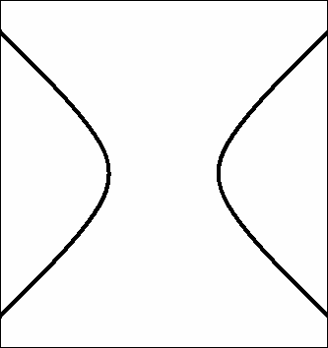
d₂

d₁
Focus
(x, y)
Focus
d₂ - d₁ is a constant.

Vertex

c
Focus
Focus
Branch
Branch
Center
Transverse
axis

a

- The midpoint between the foci is the center.

- The line segment joining the vertices is the transverse axis.

- The points at which the line through the foci meets the hyperbola are the vertices.

- The graph of the hyperbola has two disconnected branches.

- The vertices are a units from the center.

- The foci are c units from the center.
Standard Equation of a Hyperbola

The standard form of the equation of a hyperbola centered at (h, k) is

$\frac{(x−h)^{2}}{a^{2}}−\frac{(y−k)^{2}}{b^{2}}=1$ Transverse axis is horizontal

$\frac{(y−k)^{2}}{a^{2}}−\frac{(x−h)^{2}}{b^{2}}=1$ Transverse axis is vertical

The vertices are a units from the center, and the foci are c units from the center, with $c^{2}=a^{2}+b^{2}$. If the center is at the origin (0, 0), the equation takes one of the following forms.

$\frac{x^{2}}{a^{2}}−\frac{y^{2}}{b^{2}}=1$ Transverse axis is horizontal

$\frac{y^{2}}{a^{2}}−\frac{x^{2}}{b^{2}}=1$ Transverse axis is vertical
Note: $a$ is not always the larger number.

$\frac{(x−h)^{2}}{a^{2}}−\frac{(y−k)^{2}}{b^{2}}=1$ $\frac{(y−k)^{2}}{a^{2}}−\frac{(x−h)^{2}}{b^{2}}=1$

(h, k)
(h, k)
(h, k+c)
(h, k-c)
(h+c, k)
(h-c, k)
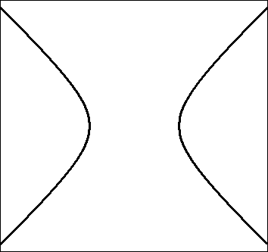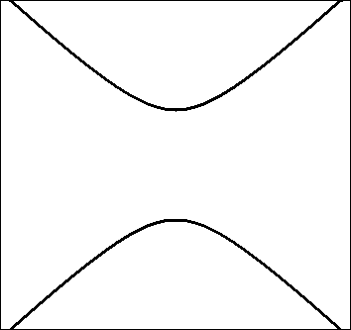

*In general, if the x-term is listed first, both branches of the hyperbola will cross the x-axis. If the y-term is listed first, both branches of the hyperbola will cross the y-axis.

What about b?

The value of b aids us in graphing the hyperbola by helping us find the asymptotes.

Asymptotes of a Hyperbola

Each hyperbola has two asymptotes that intersect at the center of the hyperbola. The asymptotes pass through the vertices of a rectangle formed using the values of a and b and centered at (h, k).
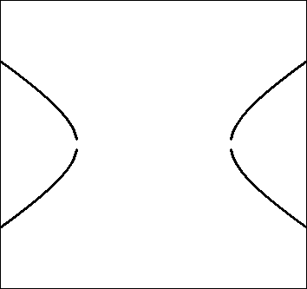
(h, k)
a
b
asymptote
asymptote

Looking at the graph, and using $\text{slope}=\frac{\text{rise}}{\text{run}}$, we can see that the slope of the asymptotes is $±\frac{b}{a}$. This will always be the case when the transverse axis is horizontal. When the transverse axis is vertical the slope = $±\frac{a}{b}$.

Example: Sketch the hyperbola given by the equation

$$\frac{(x−2)^{2}}{\text{25}}−\frac{(y−3)^{2}}{4}=1$$

Solution:

- The center is at (2, 3).
- The hyperbola opens right and left because the x-term is listed first.
- The transverse axis is 10 units, as a = 5
- The value of b is 2
- Draw the box by going
  - 5 units right and left from the center
  - 2 units up and down from the center
- Sketch the asymptotes. Then sketch the hyperbola.

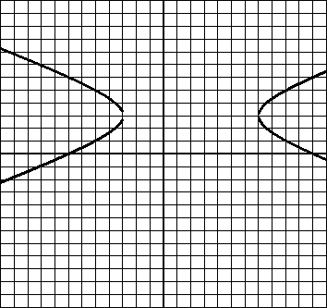

Example: Sketch the hyperbola given by the equation

$$\frac{(y−2)^{2}}{\text{16}}−\frac{(x+5)^{2}}{9}=1$$
Solution:

- The center is at (-5, 2).
- The hyperbola opens up and down because the y-term is listed first.
- The transverse axis is 8 units, as a = 4
- Draw the box, using a = 4 and b = 3.
- Sketch the asymptotes and then the hyperbola.

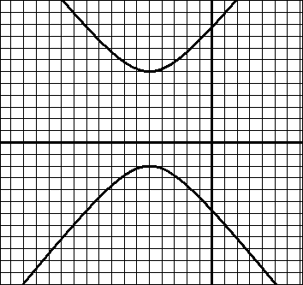

Example: Sketch the graph of the hyperbola given by $x^{2}−9y^{2}=9$

Solution: Divide through by 9 to get 1 on the right.

$$\begin{aligned}x^{2}−9y^{2}=9 \\ \frac{x^{2}}{9}−\frac{y^{2}}{1}=1\end{aligned}$$

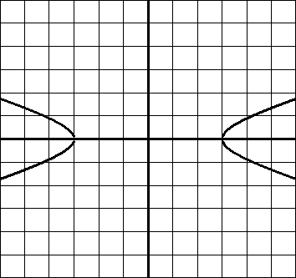

Example: Find the standard form of the equation of the hyperbola with foci (-1, 2) and (5, 2) and vertices (0, 2) and (4, 2).

Solution: Sketch the given information. You will see that

- The center must be (2, 2).
- The transverse axis is horizontal.
- The standard equation must be of the form

$$\frac{(x−h)^{2}}{a^{2}}−\frac{(y−k)^{2}}{b^{2}}=1$$

We know that a = 2 and c = 3, so we can find b.

$\begin{aligned}c^{2}=a^{2}+b^{2} \\ 3^{2}=2^{2}+b^{2} \\ 9−4=b^{2} \\ b=\sqrt{5}\end{aligned}$

Therefore, our equation must be

$$\frac{(x−2)^{2}}{4}−\frac{(y−2)^{2}}{5}=1$$

